**Bioanalytical methods and bioseparation**

The Beer-Lambert law relates the attenuation of light to the properties of the material through which the light is traveling. This page takes a brief look at the Beer-Lambert Law and explains the use of the terms absorbance and molar absorptivity relating to UV-visible absorption spectrometry.

The Absorbance of a Solution

For each wavelength of light passing through the spectrometer, the intensity of the light passing through the reference cell is measured. This is usually referred to as Io - that's I for Intensity.

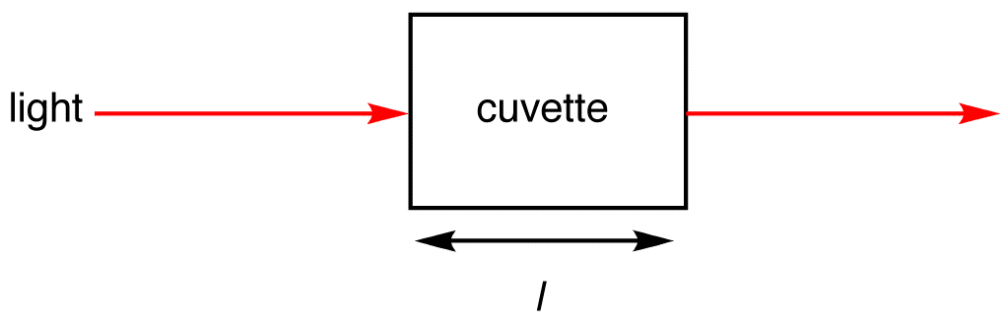

***Figure***1.11.1***:****Light absorbed by sample in a cuvetter*

The intensity of the light passing through the sample cell is also measured for that wavelength - given the symbol, I. If I is less than Io, then the sample has absorbed some of the light (neglecting reflection of light off the cuvetter surface). A simple bit of math is then done in the computer to convert this into something called the absorbance of the sample - given the symbol, A. The absorbance of a transition depends on two external assumptions.

1. The absorbance is directly proportional to the concentration (c) of the solution of the sample used in the experiment.
2. The absorbance is directly proportional to the length of the light path (l), which is equal to the width of the cuvette.

**Assumption one** relates the absorbance to concentration and can be expressed as

A ∝ c

The absorbance (A) is defined via the incident intensity Io and transmitted intensity I by

A= log10 (Io/I)

**Assumption two** can be expressed as

A ∝ l

Therefore

A ∝ c l

This proportionality can be converted into an equality by including a proportionality constant (ϵ).

A =ϵ c l

This formula is the common form of the *Beer-Lambert Law*, although it can be also written in terms of intensities:

A= log10 (Io/I) = ϵ l c

The ϵ is the molar absorptivity or molar extinction coefficient and is a measure of the probability of the electronic transition. Absorbance ranges from 0 to 1 but it can go higher. An absorbance of 0 is an indication that no light of a particular wavelength has been absorbed. The inetsities of the sample and reference are usually the same in such a case so that the ratio of Io/I is 1 and the log10 of 1 is zero

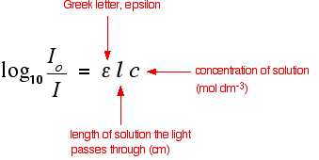

The larger the molar absorptivity, the more probable the electronic transition.  In UV spectroscopy, the concentration of the sample solution is measured in molL-1 and the length of the light path in cm. Thus, given that absorbance is unitless, the units of molar absorptivity are L mol-1 cm-1.  However, since the units of molar absorptivity is always the above, it is customarily reported without units. Absorbance does not therefore have measurement units.

**Importance of concentration in beer lamberts law**

The proportion of the light absorbed will depend on how many molecules it interacts with. Suppose you have got a strongly colored organic dye. If it is in a reasonably concentrated solution, it will have a very high absorbance because there are lots of molecules to interact with the light. However, in an incredibly dilute solution, it may be very difficult to see that it is colored at all. The absorbance is going to be very low. Therefore, absorbance is directly proportional to concentration of a solution and the higher the absorbance the higher the concentration of solution.

**The importance of the container shape**

Suppose this time that you had a very dilute solution of the dye in a cube-shaped container so that the light traveled 1 cm through it. The absorbance is not likely to be very high. On the other hand, suppose you passed the light through a tube 100 cm long containing the same solution. More light would be absorbed because it interacts with more molecules. Again, if you want to draw sensible comparisons between solutions, you have to allow for the length of the solution the light is passing through. Both concentration and solution length are allowed for in the Beer-Lambert Law. Usually a cuvette of 1 cm length is used hence absorbance is directly proportional to lenth of the solution.

**Applications of UV spectrophotometry in medicine**

Spectrophotometry can “provide a platform for diagnosing bilirubin, hemoglobin, and glucose in the serum of the blood. One of the first diagnostic tests performed on newborns is the determination of bilirubin and hemoglobin in the blood. These early indicators alert medical staff to potentially dangerous imbalances which cause jaundice and other dangerous complications in infants. With early diagnosis and treatment, many of these complications are treatable and adverse effects can be reversed. Hemoglobin and bilirubin molecules will have their own characteristic absorption spectra and can absorb light at different wavelengths. This ability can be manipulated allowing one to determine the concentration of hemoglobin and bilirubin in blood and to come up with a proper diagnosis for early treatment. Advantage of spectrophotometry in this case is there are several different methods used to test the concentration of bilirubin and hemoglobin in blood samples, but most are labor intensive and not do provide a practical method for routine analysis.Studies have shown that direct [spectrophotometry offers a simple and rapid analysis that requires only minimal sample preparation and use](http://www.hunterlab.com/blog/?p=838). This same method of analysis can also be applied to glucose measurement which is critical in monitoring blood sugar levels in the diagnosis and treatment of diabetes. Glucose absorbs UV light at a wavelength and this can enable determination of its concentration in different body fluids.

**Chromatographic techniques**

Chromatography is the collective term for a set of separation techniques that operate based on the differential partitioning of mixture components between a mobile and a stationary phase. The mobile phase (a liquid or a gas) travels through the stationary phase (a liquid or a solid) in a defined direction. The distribution of components between the two phases depends on adsorption, ionic interactions, diffusion, solubility or, in the case of affinity chromatography, specific interactions. Depending on the experimental design, the separation in a liquid mobile phase may be carried out via column or planar chromatography, on analytical or preparative scales.

Chromatographic methods are important in the analytical and preparative separation of biological samples. Gel filtration chromatography (size exclusion chromatography) is often the method of choice to purify macromolecules, taking advantage of their different sizes and shapes. Ion exchange chromatography is also useful for the separation of macromolecules, operating based on the various net charges on their surface, which can be tuned via the pH of the medium. Biological specificity in enzyme-substrate, enzyme-inhibitor, receptor-ligand, antigen-antibody (and other) interactions is utilised in affinity chromatography. In this method, one interaction partner is immobilised on a solid surface (stationary phase) and can selectively bind its interacting partner from a mixture in the mobile phase. The other components of the mixture can then be removed by replacing the mobile phase (washing). The pure material is then eluted by applying a mobile phase that disrupts the specific interaction.

Partition Chromatography

Partition chromatography has been one of the most significant classes of separation methods since its development by Martin and Synge in the 1940s. They were awarded by Nobel Prize in Chemistry in 1952, which highlights the importance of their discovery. All partition chromatography techniques apply the same principle: there are two phases, one stationary and one mobile, and the sample is partitioned between these two phases, based on their greater affinity to either one. Mobile phase can be liquid or gaseous. Partition chromatography has been used in industrial scale since 1960s. Nowadays it is the main workhorse in downstream operations of bioprocessing whenever high levels of purity are needed, such as in the production of recombinant proteins

**Adsorption Chromatography**

The stationary phase of this particular technique is a solid material on which the sample compounds are adsorbed. Mobile phase is either a liquid (solid-liquid chromatography) or a gas (gas-solid chromatography). Adsorption is completely different from absorption. In here molecules are adsorb to a surface however molecules will not become a part of this section. Adsorption chromatography is based on the interaction between the solute molecules and active sites on the stationary phase. This attachment or interaction depends on the polarity of solutes. This techniques proves the statement that “polar like polar”. Because if the stationary phase is more polar than the mobile phase then high polar compounds in the mixture will tightly bound to the stationary phase where as less polar compounds will lightly bound to the stationary phase. Less tightly bound compounds will be eluted out by the mobile phase earlier than the tightly bonded ones. Thin layer chromatography, Open column chromatography and gas chromatography come under this chromatography type.

**Difference Between Adsorption and Partition Chromatography**

**Adsorption and Partition chromatographic** techniques are based on different principles however both of them are efficient analytical techniques for the separation of components over a stationary phase with mobile phase on the components. In partition chromatography, separation on the stationary phase occurs by partition whereas adsorption chromatography is based on adsorption. Both of these techniques are based on the nature of component and samples.   
  
However partition chromatography is higher or well-developed techniques used for separation of component. Adsorption chromatography is based on the relative differences in adsorption of constituents of given sample. Because of differences in their affinity towards stationary phase, the components of the mixture adsorb with different rates. Adsorption stands for the physical bonding between the mobile and stationary phase. Polarity of compounds determines the adsorption tendency of them. This technique can be used only for solid-liquid or solid-gas chromatography.   
  
On the other hand, partition chromatography involves the separation of components by the distribution of them between two liquid phases. Components get separated due to differences in partition coefficients.

**Paper chromatography**

Paper chromatography is a type of adsorption chromatography

In paper chromatography, the stationary phase is a special quality paper called chromatography paper. Mobile phase is a solvent or a mixture of solvents. A solution of the mixture is spotted on a line about 2 cm above from the bottom of the paper, called original line or base line and then suspended in a chromatography chamber containing suitable solvent. The solvent rises up the paper by capillary action and flows over the spot. The paper selectively retains different components according to their differing partition in the two phases. The paper strip so developed is called Chromatogram. The spots of the separated coloured compounds are visible at different heights from the position of initial spot on the chromatogram. The spots of the separated colourless components may be observed either under ultraviolet light or by the use of an appropriate spray reagent such as ninhydrin which colors the colourless samples such as proteins blue and enables their visualization. The distance travelled by the solvent from the original line is called solvent front. The relative adsorption of each component of the mixture is expressed in terms of its Retardation factor (Rf) (Retention factor).

«math xmlns=¨http://www.w3.org/1998/Math/MathML¨»«msub»«mi mathvariant=¨normal¨»R«/mi»«mi mathvariant=¨normal¨»f«/mi»«/msub»«mo»=«/mo»«mfrac»«mrow»«mi mathvariant=¨normal¨»D«/mi»«mi mathvariant=¨normal¨»i«/mi»«mi mathvariant=¨normal¨»s«/mi»«mi mathvariant=¨normal¨»tan«/mi»«mi mathvariant=¨normal¨»c«/mi»«mi mathvariant=¨normal¨»e«/mi»«mo»§nbsp;«/mo»«mi mathvariant=¨normal¨»t«/mi»«mi mathvariant=¨normal¨»r«/mi»«mi mathvariant=¨normal¨»a«/mi»«mi mathvariant=¨normal¨»v«/mi»«mi mathvariant=¨normal¨»e«/mi»«mi mathvariant=¨normal¨»l«/mi»«mi mathvariant=¨normal¨»l«/mi»«mi mathvariant=¨normal¨»e«/mi»«mi mathvariant=¨normal¨»d«/mi»«mo»§nbsp;«/mo»«mi mathvariant=¨normal¨»b«/mi»«mi mathvariant=¨normal¨»y«/mi»«mo»§nbsp;«/mo»«mi mathvariant=¨normal¨»t«/mi»«mi mathvariant=¨normal¨»h«/mi»«mi mathvariant=¨normal¨»e«/mi»«mo»§nbsp;«/mo»«mi mathvariant=¨normal¨»c«/mi»«mi mathvariant=¨normal¨»o«/mi»«mi mathvariant=¨normal¨»m«/mi»«mi mathvariant=¨normal¨»p«/mi»«mi mathvariant=¨normal¨»o«/mi»«mi mathvariant=¨normal¨»n«/mi»«mi mathvariant=¨normal¨»e«/mi»«mi mathvariant=¨normal¨»n«/mi»«mi mathvariant=¨normal¨»t«/mi»«mo»§nbsp;«/mo»«mi mathvariant=¨normal¨»f«/mi»«mi mathvariant=¨normal¨»r«/mi»«mi mathvariant=¨normal¨»o«/mi»«mi mathvariant=¨normal¨»m«/mi»«mo»§nbsp;«/mo»«mi mathvariant=¨normal¨»t«/mi»«mi mathvariant=¨normal¨»h«/mi»«mi mathvariant=¨normal¨»e«/mi»«mo»§nbsp;«/mo»«mi mathvariant=¨normal¨»o«/mi»«mi mathvariant=¨normal¨»r«/mi»«mi mathvariant=¨normal¨»i«/mi»«mi mathvariant=¨normal¨»g«/mi»«mi mathvariant=¨normal¨»i«/mi»«mi mathvariant=¨normal¨»n«/mi»«mi mathvariant=¨normal¨»a«/mi»«mi mathvariant=¨normal¨»l«/mi»«mo»§nbsp;«/mo»«mi mathvariant=¨normal¨»l«/mi»«mi mathvariant=¨normal¨»i«/mi»«mi mathvariant=¨normal¨»n«/mi»«mi mathvariant=¨normal¨»e«/mi»«/mrow»«mrow»«mi mathvariant=¨normal¨»D«/mi»«mi mathvariant=¨normal¨»i«/mi»«mi mathvariant=¨normal¨»s«/mi»«mi mathvariant=¨normal¨»tan«/mi»«mi mathvariant=¨normal¨»c«/mi»«mi mathvariant=¨normal¨»e«/mi»«mo»§nbsp;«/mo»«mi mathvariant=¨normal¨»t«/mi»«mi mathvariant=¨normal¨»r«/mi»«mi mathvariant=¨normal¨»a«/mi»«mi mathvariant=¨normal¨»v«/mi»«mi mathvariant=¨normal¨»e«/mi»«mi mathvariant=¨normal¨»l«/mi»«mi mathvariant=¨normal¨»l«/mi»«mi mathvariant=¨normal¨»e«/mi»«mi mathvariant=¨normal¨»d«/mi»«mo»§nbsp;«/mo»«mi mathvariant=¨normal¨»b«/mi»«mi mathvariant=¨normal¨»y«/mi»«mo»§nbsp;«/mo»«mi mathvariant=¨normal¨»t«/mi»«mi mathvariant=¨normal¨»h«/mi»«mi mathvariant=¨normal¨»e«/mi»«mo»§nbsp;«/mo»«mi mathvariant=¨normal¨»s«/mi»«mi mathvariant=¨normal¨»o«/mi»«mi mathvariant=¨normal¨»l«/mi»«mi mathvariant=¨normal¨»v«/mi»«mi mathvariant=¨normal¨»e«/mi»«mi mathvariant=¨normal¨»n«/mi»«mi mathvariant=¨normal¨»t«/mi»«mo»§nbsp;«/mo»«mi mathvariant=¨normal¨»f«/mi»«mi mathvariant=¨normal¨»r«/mi»«mi mathvariant=¨normal¨»o«/mi»«mi mathvariant=¨normal¨»m«/mi»«mo»§nbsp;«/mo»«mi mathvariant=¨normal¨»t«/mi»«mi mathvariant=¨normal¨»h«/mi»«mi mathvariant=¨normal¨»e«/mi»«mo»§nbsp;«/mo»«mi mathvariant=¨normal¨»o«/mi»«mi mathvariant=¨normal¨»r«/mi»«mi mathvariant=¨normal¨»i«/mi»«mi mathvariant=¨normal¨»g«/mi»«mi mathvariant=¨normal¨»i«/mi»«mi mathvariant=¨normal¨»n«/mi»«mi mathvariant=¨normal¨»a«/mi»«mi mathvariant=¨normal¨»l«/mi»«mo»§nbsp;«/mo»«mi mathvariant=¨normal¨»l«/mi»«mi mathvariant=¨normal¨»i«/mi»«mi mathvariant=¨normal¨»n«/mi»«mi mathvariant=¨normal¨»e«/mi»«/mrow»«/mfrac»«/math»

**Ascending and Descending Paper Chromatography**

The type of paper chromatography in which the solvent rises up is called Ascending paper chromatography. Alternatively, the solvent may be taken on the top in a container and be allowed to come down, in which case it is termed as Descending paper chromatography.  Below is shown the ascending paper chormatography.

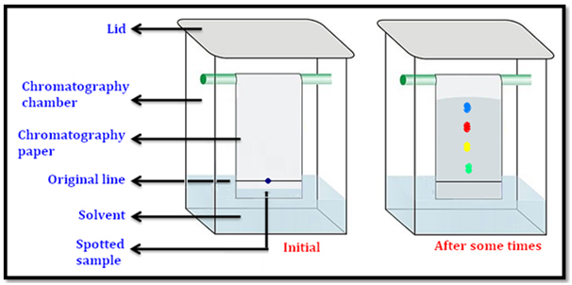

**Thin layer chromatography**

Thin layer chromatography is another type of adsorption chromatography, which involves the separation of a mixture of substances over a thin layer of an adsorbent coated on a glass plate such as silica oxide. In this case, the stationary phase is a glass plate of suitable size coated with a thin layer of stationary phase usually silica gel or alumina. This plate is known as thin layer chromatography plate (TLC plate) or chromaplate. The solution of mixture to be separated is applied as a small spot about 2 cm above one end of the TLC plate. The glass plate is then placed in a closed jar (chromatography chamber) containing the mobile phase. As the mobile phase rises up the plate by capillary action, the components of the mixture move up along with the solvent to different distances depending on their degree of adsorption and separation takes place. The relative adsorption of each component of the mixture is expressed in terms of its Retardation factor (Rf) (Retention factor).

What is Retention factor (Rf value)?

It is defined as the distance moved up or travelled by the component from the original line to the distance travelled by the solvent from the original line.

«math xmlns=¨http://www.w3.org/1998/Math/MathML¨»«msub»«mi mathvariant=¨normal¨»R«/mi»«mi mathvariant=¨normal¨»f«/mi»«/msub»«mo»=«/mo»«mfrac»«mrow»«mi mathvariant=¨normal¨»D«/mi»«mi mathvariant=¨normal¨»i«/mi»«mi mathvariant=¨normal¨»s«/mi»«mi mathvariant=¨normal¨»tan«/mi»«mi mathvariant=¨normal¨»c«/mi»«mi mathvariant=¨normal¨»e«/mi»«mo»§nbsp;«/mo»«mi mathvariant=¨normal¨»t«/mi»«mi mathvariant=¨normal¨»r«/mi»«mi mathvariant=¨normal¨»a«/mi»«mi mathvariant=¨normal¨»v«/mi»«mi mathvariant=¨normal¨»e«/mi»«mi mathvariant=¨normal¨»l«/mi»«mi mathvariant=¨normal¨»l«/mi»«mi mathvariant=¨normal¨»e«/mi»«mi mathvariant=¨normal¨»d«/mi»«mo»§nbsp;«/mo»«mi mathvariant=¨normal¨»b«/mi»«mi mathvariant=¨normal¨»y«/mi»«mo»§nbsp;«/mo»«mi mathvariant=¨normal¨»t«/mi»«mi mathvariant=¨normal¨»h«/mi»«mi mathvariant=¨normal¨»e«/mi»«mo»§nbsp;«/mo»«mi mathvariant=¨normal¨»c«/mi»«mi mathvariant=¨normal¨»o«/mi»«mi mathvariant=¨normal¨»m«/mi»«mi mathvariant=¨normal¨»p«/mi»«mi mathvariant=¨normal¨»o«/mi»«mi mathvariant=¨normal¨»n«/mi»«mi mathvariant=¨normal¨»e«/mi»«mi mathvariant=¨normal¨»n«/mi»«mi mathvariant=¨normal¨»t«/mi»«mo»§nbsp;«/mo»«mi mathvariant=¨normal¨»f«/mi»«mi mathvariant=¨normal¨»r«/mi»«mi mathvariant=¨normal¨»o«/mi»«mi mathvariant=¨normal¨»m«/mi»«mo»§nbsp;«/mo»«mi mathvariant=¨normal¨»t«/mi»«mi mathvariant=¨normal¨»h«/mi»«mi mathvariant=¨normal¨»e«/mi»«mo»§nbsp;«/mo»«mi mathvariant=¨normal¨»o«/mi»«mi mathvariant=¨normal¨»r«/mi»«mi mathvariant=¨normal¨»i«/mi»«mi mathvariant=¨normal¨»g«/mi»«mi mathvariant=¨normal¨»i«/mi»«mi mathvariant=¨normal¨»n«/mi»«mi mathvariant=¨normal¨»a«/mi»«mi mathvariant=¨normal¨»l«/mi»«mo»§nbsp;«/mo»«mi mathvariant=¨normal¨»l«/mi»«mi mathvariant=¨normal¨»i«/mi»«mi mathvariant=¨normal¨»n«/mi»«mi mathvariant=¨normal¨»e«/mi»«/mrow»«mrow»«mi mathvariant=¨normal¨»D«/mi»«mi mathvariant=¨normal¨»i«/mi»«mi mathvariant=¨normal¨»s«/mi»«mi mathvariant=¨normal¨»tan«/mi»«mi mathvariant=¨normal¨»c«/mi»«mi mathvariant=¨normal¨»e«/mi»«mo»§nbsp;«/mo»«mi mathvariant=¨normal¨»t«/mi»«mi mathvariant=¨normal¨»r«/mi»«mi mathvariant=¨normal¨»a«/mi»«mi mathvariant=¨normal¨»v«/mi»«mi mathvariant=¨normal¨»e«/mi»«mi mathvariant=¨normal¨»l«/mi»«mi mathvariant=¨normal¨»l«/mi»«mi mathvariant=¨normal¨»e«/mi»«mi mathvariant=¨normal¨»d«/mi»«mo»§nbsp;«/mo»«mi mathvariant=¨normal¨»b«/mi»«mi mathvariant=¨normal¨»y«/mi»«mo»§nbsp;«/mo»«mi mathvariant=¨normal¨»t«/mi»«mi mathvariant=¨normal¨»h«/mi»«mi mathvariant=¨normal¨»e«/mi»«mo»§nbsp;«/mo»«mi mathvariant=¨normal¨»s«/mi»«mi mathvariant=¨normal¨»o«/mi»«mi mathvariant=¨normal¨»l«/mi»«mi mathvariant=¨normal¨»v«/mi»«mi mathvariant=¨normal¨»e«/mi»«mi mathvariant=¨normal¨»n«/mi»«mi mathvariant=¨normal¨»t«/mi»«mo»§nbsp;«/mo»«mi mathvariant=¨normal¨»f«/mi»«mi mathvariant=¨normal¨»r«/mi»«mi mathvariant=¨normal¨»o«/mi»«mi mathvariant=¨normal¨»m«/mi»«mo»§nbsp;«/mo»«mi mathvariant=¨normal¨»t«/mi»«mi mathvariant=¨normal¨»h«/mi»«mi mathvariant=¨normal¨»e«/mi»«mo»§nbsp;«/mo»«mi mathvariant=¨normal¨»o«/mi»«mi mathvariant=¨normal¨»r«/mi»«mi mathvariant=¨normal¨»i«/mi»«mi mathvariant=¨normal¨»g«/mi»«mi mathvariant=¨normal¨»i«/mi»«mi mathvariant=¨normal¨»n«/mi»«mi mathvariant=¨normal¨»a«/mi»«mi mathvariant=¨normal¨»l«/mi»«mo»§nbsp;«/mo»«mi mathvariant=¨normal¨»l«/mi»«mi mathvariant=¨normal¨»i«/mi»«mi mathvariant=¨normal¨»n«/mi»«mi mathvariant=¨normal¨»e«/mi»«/mrow»«/mfrac»«/math»

To detect the samples

* The spots of coloured components are visible on the TLC plate due to their original colour. The spots of colourless components that are invisible to the eye but fluorescent in ultraviolet light can be detected by putting the plate under ultraviolet light.
* Another detection technique is to place the plate in a covered jar containing few crystals of iodine, spots of the components that absorb iodine, will seen as brown spots.
* Another method is to spray an appropriate reagent on the TLC plate. For example, amino acids may be detected by spraying the plate with ninhydrin solution.

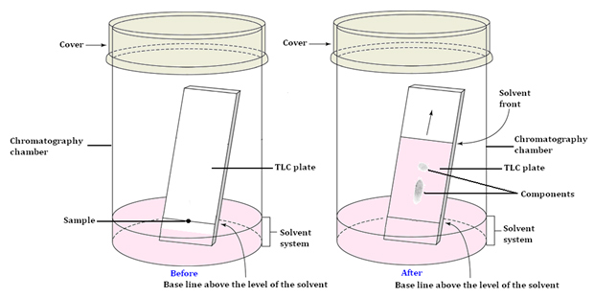

**Ion exchange chromatography**

This is to separate ionic mixtures. The stationary phase of this technique is an ion-exchange resins where as the mobile phase is a buffered aqueous solution. Anions or cations can covalently attach onto the resin. The resin can be either cationic or anionic. Solute ions of the opposite charge in the mobile phase attach to the resin by electrostatic forces. Ion exchange columns are of two types. Those are cation exchange columns (contains negatively charged groups) eg Carboxymethyl cellulose colums and Anion exchange columns (contain positively charged groups) eg Diethylaminoethyl-cellulose columns . In here the charged analytes are attached to the counter ions (exchange groups) in the column. Analyte ions are eluted out using a buffer with a different pH (to weaken the electrostatic interactions between the analytes and the exchangers. Analytes are present in the mobile phase where as the exchange groups present in the column

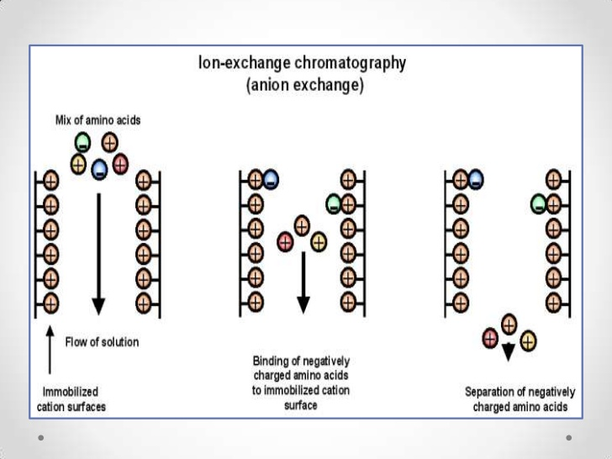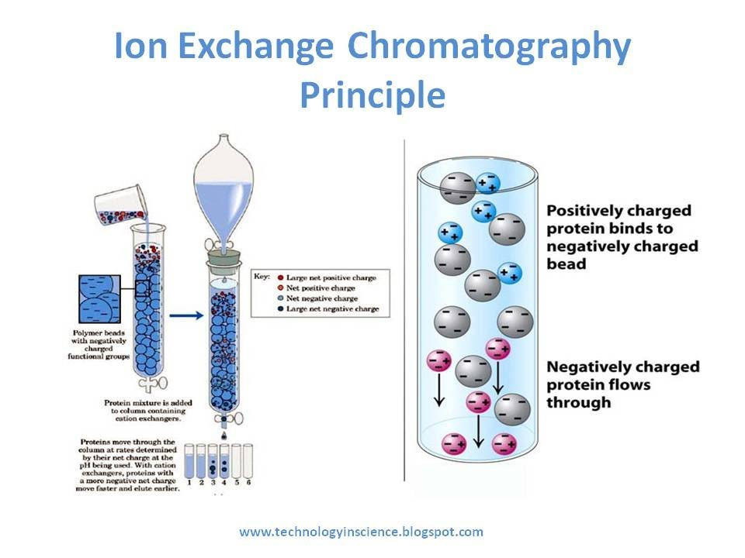

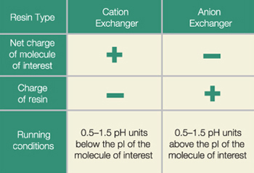

**Size exclusion/ Gel filtration chromatography**

Gel filtration chromatography separates proteins, peptides, and oligonucleotides on the basis of size. Molecules move through a bed of porous beads, diffusing into the beads to greater or lesser degrees. Smaller molecules diffuse further into the pores of the beads and therefore move through the bed more slowly, while larger molecules enter less or not at all and thus move through the bed more quickly. Both molecular weight and three-dimensional shape contribute to the degree of retention. Gel Filtration Chromatography may be used for analysis of molecular size, for separations of components in a mixture, or for salt removal or buffer exchange from a preparation of macromolecules.

Unlike ion exchange chromatography, gel filtration does not depend on any chemical interaction with protein, rather it is based on a physical property of the protein - that being the effective molecular radius (which relates to mass for most globular proteins). Size exclusion chromatography (SEC) is the separation of mixtures based on the molecular size (more correctly, their hydrodynamic volume) of the components. Separation is achieved by the differential exclusion or inclusion of solutes as they pass through stationary phase consisting of heteroporous (pores of different sizes) cross linked polymeric gels or beads. The process is based upon different permeation rates of each solute molecule into the interior of gel particles. Size exclusion chromatography involves gentle interaction with the sample, enabling high retention of biomolecular activity. For the separation of biomolecules in aqueous systems, SEC is referred to as gel filtration chromatography (GFC), while the separation of organic polymers in non-aqueous systems is called gel permeation chromatography (GPC).

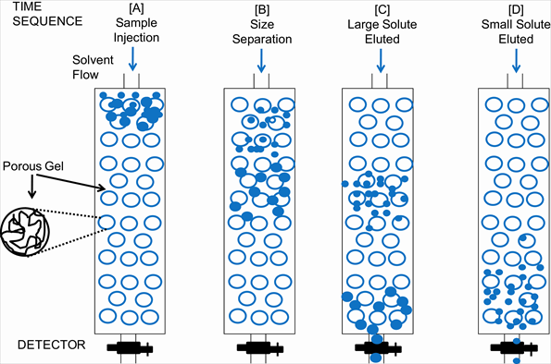

Separation of biomolecules by size exclusion chromatography

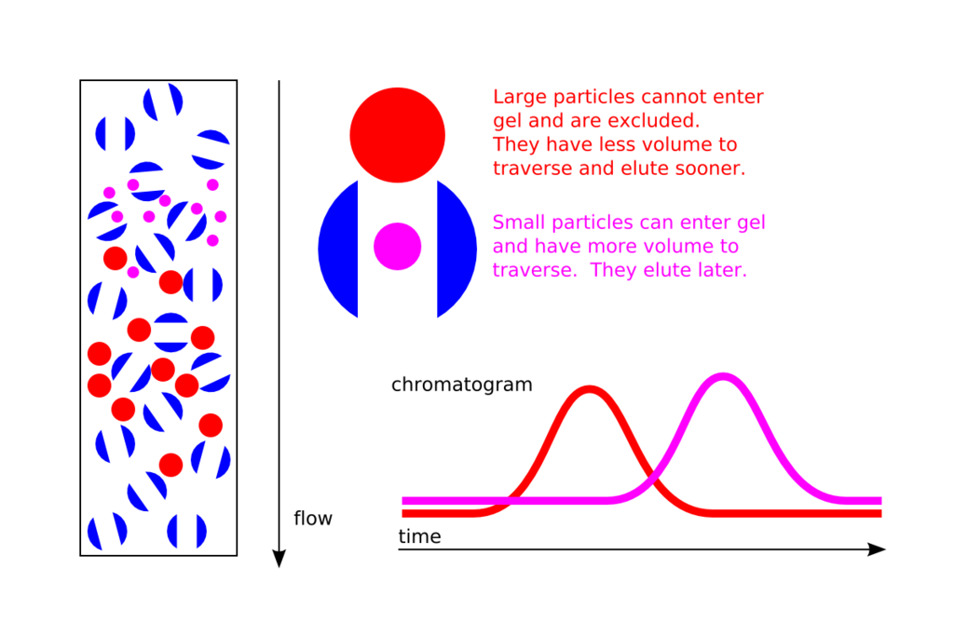

**Affinity Chromatography**

By affinity chromatography, high-selectivity separation of biomolecules can be achieved through their specific interactions. This separation technique is special because it is based on the biological function or the unique chemical structure of a given biomolecule. During affininty chromatography, the interacting partner of the biomolecule is immobilised on a chromatographic resin. This ligand, fixed to the stationary phase, reversibly binds the desired biomolecule present in the multi-component mobile phase. The materials can be eluted from the column by changing the composition of the mobile phase.

The technique provides high selectivity, high resolution and generally high capacity for the desired protein. The degree of purification can be thousands of times, and the achieved yield can also be usually very good.

Affinity chromatography, as already mentioned, is unique in the sense that it is based on the specific biological function of the biomolecule of interest. This feature also makes affinity chromatography suitable for the selective separation of active biomolecules, and their isolation from the inactive or denatured forms.

Another significant advantage of the method is that, in many cases, it allows for single-step isolation of the desired biomolecule. However, it is required that the sample to be separated should be a clear solution free of large particles. It is often advisable to prepare the sample for affinity chromatography via an initial partial separation. For instance, in the case of affinity isolation of very scarce components of the blood serum, it is advisable to perform an initial separation to eliminate serum albumin (which makes up more than 50 % of the serum protein content).

Affinity chromatographic purification is frequently of great importance in the case of recombinant proteins. Recombinant proteins are often produced in a way that they contain a fused “label” at their N- or C-terminus, resulting from genetic engineering. This way, if the label endows the protein to enter into affinity binding, the recombinant protein can be simply “fished out” of the cell extract via affinity chromatography

One of the most widely used of such labels fused to protein termini is the oligo-histidine tag (His-tag), which binds reversibly to metal chelates (e.g. Ni chelate immobilised on the stationary phase). Another frequently applied tag is glutathione S-transferase (GST), a fusion protein that can be used to isolate the protein of interest using a glutathione-conjugate matrix. These specific affinity matrices are commercially available as pre-packed columns.

In other cases, the specific ligand is to be linked by the user to the chromatographic matrix. Various activated reactive chromatographic matrices are available for this purpose.

8[

*Elution of the molecules of interest by changing the composition of the mobile phase*

*Elution via pH and/or ionic strength changes:* One possible and simple means of elution is achieved through decreasing the interaction strength between the ligand and the target protein. Changes in the pH will change the ionisation state of charged groups of the ligand and/or the target protein, thereby changing the strength of the interaction. Similarly, increasing the ionic strength (usually by raising the NaCl concentration) will generally reduce the interaction strength. In either case, the solubility and stability of the target protein should be considered.

*Competitive elution:* For competitive elution, materials are applied that react with the target protein or the ligand, competing for the pre-existing interaction. For instance, His-Tag fusion proteins can be readily displaced from the metal chelate matrix by imidazole buffer (Figure 6.9). GST-tagged target proteins will detach from their column-conjugated glutathione ligand upon mixing excess glutathione into the elution buffer. In all cases, the flow rate of the buffer should be reduced during elution, thereby avoiding excessive dilution of the target protein.

After successful completion of the elution, the column can be washed with several column volumes of binding buffer, and it can then be reused. For long-term storage, one must ensure that the column is not exposed to bacterial or fungal infection. The toxic compound sodium azide can be used to prevent such infections.

Some of the commonly used interactions in affinity chromatography are listed below

|  |  |
| --- | --- |
| Enzyme | Substrate analogue or inhibitor |
| Antibody | Antigen (virus, cells) |
| Nucleic acid | Complementary nucleic acid |
| Nucleic acid | Histone or other nucleic acid binding protein |
| Hormone | Hormone receptor |
| Glutathione | Glutathione S-transferase (GST) fusion protein |
| Metal chelate | His-tag fusion protein |

